SMART on FHIR Integration Approaches
This document presents a comparative analysis of two possible architectures for implementing SMART on FHIR authentication and authorization using Keycloak in conjunction with a HAPI FHIR server. The aim is to support SMART App Launch with correct handling of scopes, patient selection, and token issuance.

✅ Solution 1: HAPI FHIR Keycloak as Broker to Leap Keycloak

Architecture Overview
- SMART App sends auth request to HAPI Keycloak (token issuer).
- HAPI Keycloak is configured with Leap Keycloak as an identity provider.
- User gets login at Leap Keycloak.
- After login, HAPI Keycloak handles:
  - Creates user if did not exist.
  - Patient selection screen.
  - Scope selection screen.
  - Access token generation with SMART-compliant claims.
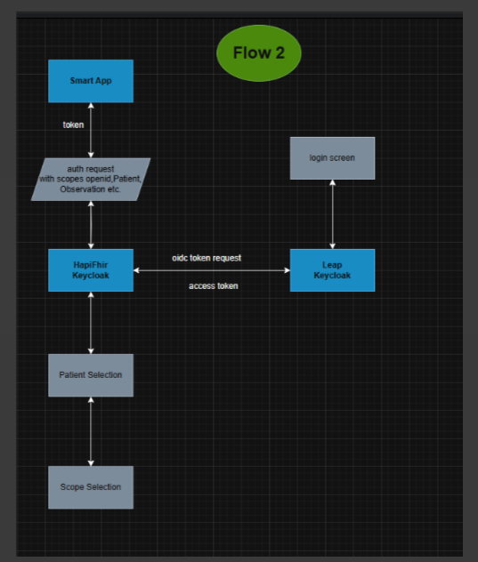

Pros
- Centralized SMART Logic: All SMART-specific handling (scope filtering, fhirUser, launch/patient) is handled in one place (HAPI Keycloak).
- No manual user creation required: No need to manually create users in HAPI Keycloak; brokering handles identity mapping.
- Extensible: Future enhancements (e.g., dynamic policy enforcement) can be added in HAPI Keycloak without touching Leap.

Cons
- Cross-domain flow: Two Keycloak redirects might confuse users (UX impact). The SMART app hits HAPI Keycloak → gets redirected to Leap → back to HAPI → then completes auth.
- Initial Login is Handled by a Different Domain Can cause confusion or visual inconsistency for users (two different URLs, one for login and one for patient/scope selection).
- Complex session management: two session created for one login, one session on Leap keyclaok and one on HAPI keycloak.
- Availability dependency: If Leap Keycloak is down, HAPI’s SMART authentication fails too.

SMART Compliance
- Fully compliant. The access token is issued by the same HAPI Keycloak instance interacting with the SMART App. All claims are populated as per the specification.

✅ Solution 2: New HAPI FHIR Instance with Leap Keycloak Directly as Auth Server

Architecture Overview
- A new instance of HAPI FHIR server is deployed, pointing to the same database as the current instance.
- This new HAPI FHIR is configured to use Leap Keycloak directly (no brokering).
- All token issuance, patient selection, and scope selection must now be handled in Leap Keycloak.

Pros
- No redirection: Clean login flow; user only interacts with Leap Keycloak.
- Simplicity: Fewer moving parts; no identity brokering.
- Single source of authentication: Leap Keycloak remains the single identity provider across all systems.
- No user sync required: Users are already in Leap, and no creation needed in the new HAPI Keycloak.

Cons
- Duplicate logic: SMART scope handling, patient selection UI, and scope mappers now must be implemented in Leap.
- Harder to reuse existing extensions: Custom mappers, authenticators, or SPI code written for HAPI Keycloak must be ported.
- Tight coupling: Makes Leap Keycloak tightly coupled with SMART logic, potentially affecting other apps using it.
- Security separation concerns: Introducing SMART-specific authorization inside Leap could affect security isolation.

SMART Compliance
- Compliant, assuming Leap Keycloak is enhanced to support:
  - Dynamic scope selection.
  - Patient selection.
  - scope, patient, and fhirUser claims in access token.
  - Proper audience (aud) and issuer (iss) settings matching FHIR server expectations.

🔄 Comparison Summary
Aspect | Solution 1: Broker Model | Solution 2: Leap as Direct Auth Server
Login UX | Multi-redirect flow | Seamless login
Token Issuer | HAPI Keycloak | Leap Keycloak
User management | Federated | Native in Leap
Patient/Scope Selection | HAPI Keycloak | Must build in Leap
SMART Compliance | ✅ Fully compliant | ✅ Compliant with customization
Maintenance Effort | Centralized | Spread across Leap
Risk of Duplication | Low | High
System Coupling | Decoupled | Tightly coupled
Future-proofing | Easier to extend SMART logic | Complex without affecting other flows

🔧 Recommendation
If long-term scalability, modularity, and clean SMART on FHIR support is the goal, Solution 1 (Broker model) is more maintainable and extensible. However, for a simplified setup with fewer redirects and minimal user management overhead, Solution 2 is viable if Leap Keycloak can be sufficiently extended to fully implement SMART-specific logic.

